Directions to Register & Sign-On to the
Scott Foresman/Pearson SuccessNet Web Site

- Go to http://www.pearsonsuccessnet.com

- Log into your SuccessNet account using your username and password.

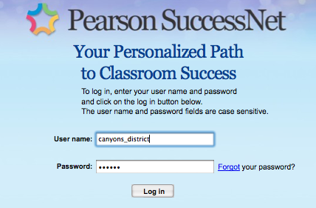
- You should now be looking at a screen similar to the one below:

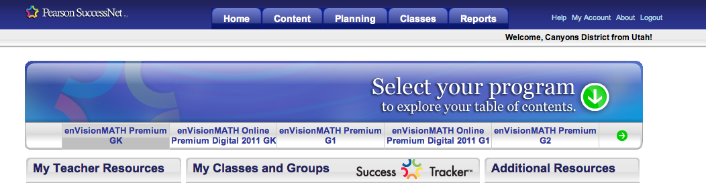
Click on “Teacher Resources”.

- Click on “Transitioning to Common Core with enVisionMATH”
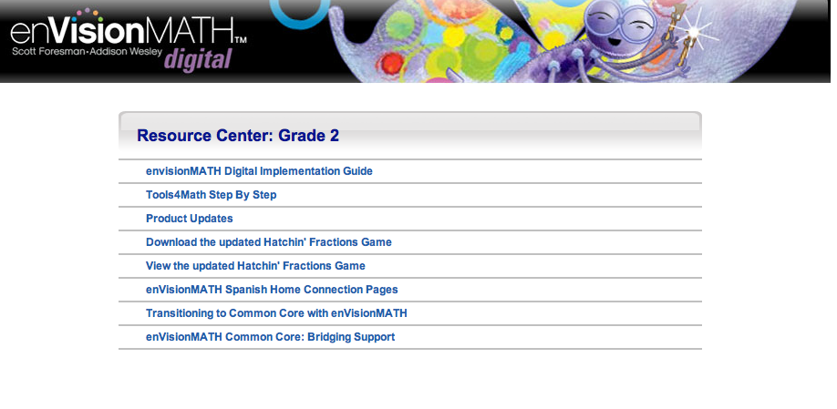

5. Click on the C-C lesson of your choice to view the following…

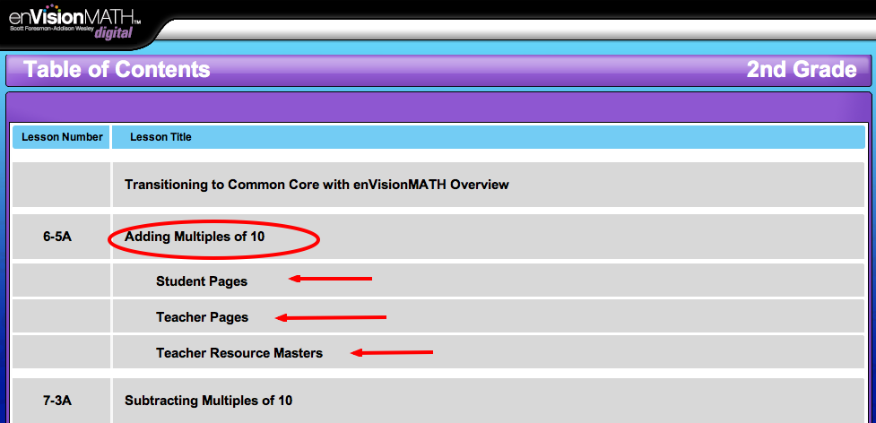

6. You now have full access to the digital C-C lessons. ☺

To learn more or to check out EnVision & SuccessNet tutorials, please visit www.myPearsonTraining.com.

