Directions to Register & Sign-On to the
Scott Foresman/Pearson SuccessNet Web Site

- Go to http://www.pearsonsuccessnet.com

- Click on: “Check your computer’s settings”
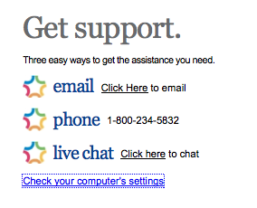

- Make sure you have the following settings enabled:
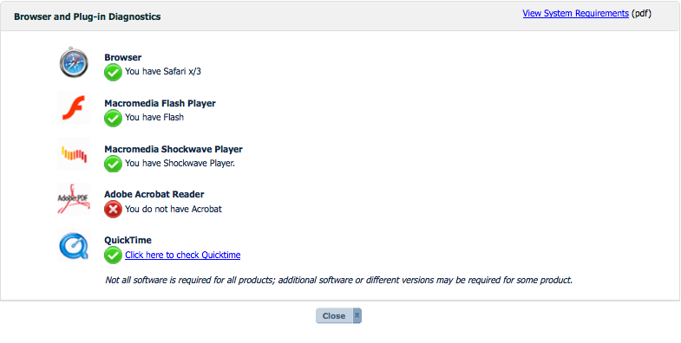
*You DO need Adobe Acrobat to successfully use enVision’s SuccessNet. If you have Adobe Reader and you get this message on your screen, it is an error and should not be of concern. If you do not have Adobe Reader, you will need to download it.
- Complete any updates you need to make and click on “close”.

- Click on the button to register.

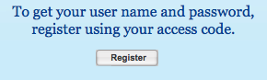

- Enter your grade level access code:

K : SFMADP11NTENGKB
1st: SFMADP11NTENG1B
2nd: SFMADP11NTENG2B
3rd: SFMADP11NTENG3B
4th: SFMADP11NTENG4B
5th: SFMADP11NTENG5B
6th: SFMADP11NTENG6B

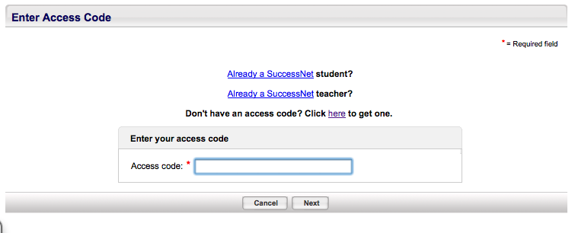
Click: “Next”

- Enter the required information on the next screen. When you put in your school’s zip code, you will see a list of schools. Choose your school from the list.
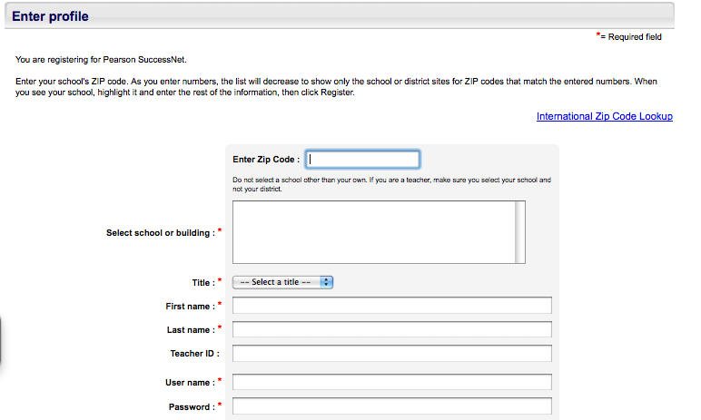
NOTE: You must enter the information with an *asterisk, but other information, such as the
TEACHER ID field, can be left blank.
Enter your name, email
address (use the district
email: ____@canyonsdistrict.org).

User name: first_last
Password: Make it one you will
remember!
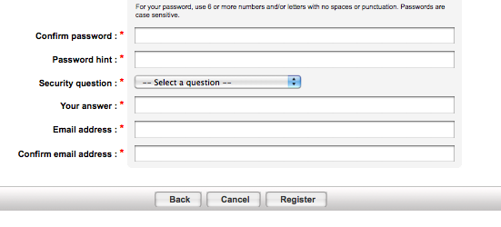
Click on “Register”

- You can now log in to your account using your username and password.

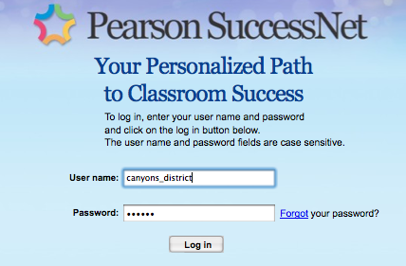
- You should now be looking at a screen similar to the one below:

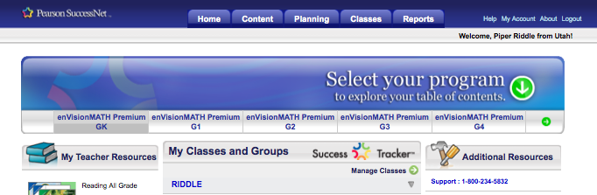

Click on “My Account”.

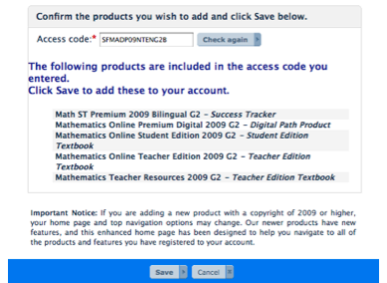

- IMPORTANT: Log out and log back in for products to appear in your account.

- Once you have logged back in, you may begin using the on-line digital resources in your library. Explore and enjoy!

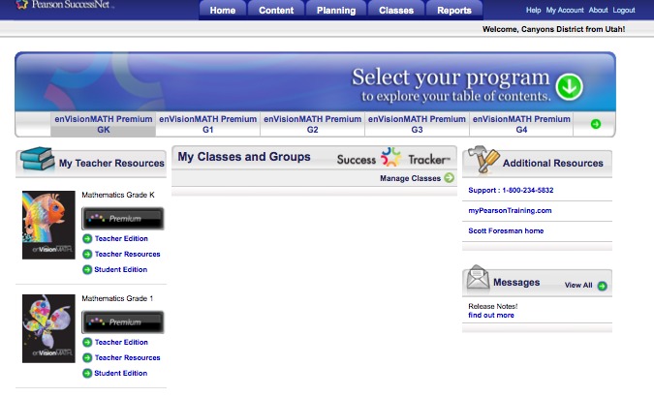

To learn more or to check out EnVision & SuccessNet tutorials, please visit www.myPearsonTraining.com.

